  EMIRATES CENTER FOR WILDLIFE PROPAGATION  Province de Boulemane - B.P. 47  33250 Missour  ROYAUME DU MAROC  Tél. : +212 (0)5 35 58 57 52  Fax : +212 (0)5 35 58 52 06  E-mail : houbara@ecwp.net.ma | Field protocol | Identification:  HB_Standardized_Display_Male_Search_compilation_EN.docx
Houbara Diplaying male search protocol on Al Baten  Compilation 2005-2014 |  | Created:  21/10/2014
Last update:
19/12/2025

Number of pages:
5

- Content

1. Content 1
2. Objectives 2
3. General principles 2
4. Conditions of application common to all protocol variations 2
5. Preliminary work 2
6. Common operating protocol from 2005 2
7. Modifications of the protocol 4
8. Observations points 5
a) From 2007 to 2010: 90 observation points 5
b) Since 2011: 96 observation points 5

- Objectives
- Identifying areas suitable for Houbara breeding;
- Identifying preferential sites for courtship display;
- Monitoring interannual variations of the number of display sites by duplicating the same protocol in a given area in order to:
    - Study Houbara mating system;
    - Understand the functioning of leks in different areas.
- General principles
The displaying male search is realized since 2006 using the method of observation points. Males are counted during a circular observation (360°) realized from reference observation point during defined observation duration.
Al Baten plain is crossed by old mining transects. Some became real tracks used by vehicles, and other tracks were created over time. To make easier the search of display sites, these tracks have been assimilated to prospection transects on which most of the observation points have been regularly distributed. The first point is placed around 500m from the beginning of the track (from the road), and the next points theoretically every 2km. Most of the observation points have been created directly on the tracks in the field. Historically, to compensate areas not covered by the tracks, additional points have been selected using GIS and then correctly placed in the field.
Each observation point is visited once in an interval of 2 weeks.
The probability to detect a displaying male will depend on 3 independent variables:
- Prospection effort;
- Constancy of the male (display duration during the day and during the season);
- Climatic conditions.
The method is based on the following premise: with an adequate prospection effort, the probability to detect a displaying male on a regular display site is 1 or close to 1.
- Conditions of application common to all protocol variations
- The displaying male search has to be realized during Houbara breeding season.
- The observation points are selected to cover the whole studied area.
- A team is constituted of 1 observer.
- The survey is conducted during hours suitable to observe displaying males: from sunrise until 3 hours after sunrise and from 2h before sunset until the sunset. However, the survey should not be carried out when detection conditions are not optimal (heat hazes, cloudiness, wind…).
- Preliminary work
- Define the observation points to use to prospect the whole area. This operation is realized only once by area, and then the validated sampling grid is considered as definitive.
- Create the map (GIS) of the grid and extract the coordinates of each observation point. These coordinates will be loaded in the fieldworkers’ GPS.
- Common operating protocol from 2005
- The observer goes to the reference observation points by using a GPS.
- The arrival on the point is made at slow speed in order not to disturb the observation area.
- The reel observation point can occasionally be moved (new field, tents…) to a reasonable distance. In this case, the observer records the modification. If the disturbance is permanent, the reference point will be modified or replaced by a new reference point.
- The observer notes on the displaying male search field sheet the name of the reference point and the begin time of the observation.
- The observer realizes a circular observation (360°) with binoculars, the telescope can be used for confirmation. The observation duration is 10 minutes.
- When a displaying male is detected with certitude, the precise location of the male is recorded by using landmarks in length and in depth.
- At the end of the circular observation, the observer goes to the locations where males have been observed using the landmarks noted during the observation. If the males moved, the observer goes to the place they were first detected from the observation point. Between each location, the observer goes back to the observation point to find back the landmarks before going to locate the next male.
- When approaching the site, the observer has to identify the male by:
    - Scanning VHF frequencies of the birds of the area;
    - Regularly observing the bird with the telescope to detect any tag (ring, colored tag, transmitter), even if no VHF signal was heard. The observation will allow confirming that the frequency really comes from the individual in the case a signal is received.
- Once on the display area, the observer takes a GPS point and records information on the displaying male search field sheet:
    - Name of the waypoint: the names are defined according to a specific code;
    - The location accuracy;
    - The display type (circular, static, line);
    - The distance to the observation point;
    - The male identification;
    - The type of landscape;
    - The 3 main vegetal species.
- The observer searches for clues such as tracks or faeces that will inform about the use intensity of the display area.
- Once all the males located, the observer leaves the observation point area and goes to the next point.
- When no males are detected, the observer goes directly to the next observation point.
- If other Houbara than displaying males are detected during the circular observation, the observer does not go to the precise location but records it with a projected GPS point or using distance and bearing. The observation is not saved in the same field sheet but in a classical Houbara observation field sheet.
- Modifications of the protocol
Tableau 1 : Evolution of different points of Houbara displaying male search protocol since 2001
Part of the protocol concerned | Year | Modification
Reference observation points | 2005 | 95 reference observations points
Reference observation points | 2006 | 97
Reference observation points | 2007-2010 | 90
Reference observation points | Since 2011 | 96
Observation point | Since 2012 | The real observation point is recorded by a GPS point.
Limit radius distance for moving the effective observation point | 2005-2009 | 500m from the original observation point
 | From 2009 | 300m from the original observation point
GPS preparation | 2005-2012 | All display observations of the current year are uploaded in the GPS each week
GPS preparation | From 2012 | Display observations are not loaded in the GPS to avoid bias in display observations locations
Created display point | 2008-2009 | - If no display site exists under 100m radius from the current observation, a new point is created  - If a display site exists under 100m radius from the current observation, the observer take the existing waypoint and replace date time by the current date time
Created display point | 2010-2012 | - If no display site exists under 100m radius from the current observation, a new point is created  - If a display site exists under 100m radius from the current observation, a new point is created with the same code as the existing waypoint
Created display point | From 2012 | A new point is created according to the current codification independently of an existing display observation nearby
Display site codification | 2005-2011 | aaPnnX :  aa = current year. For example 06 for 2006  P = parade (display)  nn = number of displays described by the observer X  X = letter attributed to the observer  ==> 05P01Y  This codification only concerns displays corresponding to what was defined as a display site (circular display)
Display site codification | 2012-2018 | Circular or static display:  DnnMxx : D = Display, nn = number of displays described by the observer, M = GPS Morocco, xx = Number of the GPS  ==> D01M26  Line display:  LnnMxx : L = Line, nn = number of displays described by the observer, M = GPS Morocco, xx = Number of the GPS  ==> L01M26
 | Since 2019 | Circular or static display:  aaMxxDnn : aa= year, M = GPS Morocco, xx = Number of the GPS, D = Display, nn = number of displays described by the observer, ==> 19M26D01  Line display:  aaMxxLnn : aa= year, M = GPS Morocco, xx = Number of the GPS, L = Line, nn = number of displays described by the observer,  ==> L01M26
Detection time | Since 2013 | The time of detection of each male is recorded

- Observations points
- From 2007 to 2010: 90 observation points
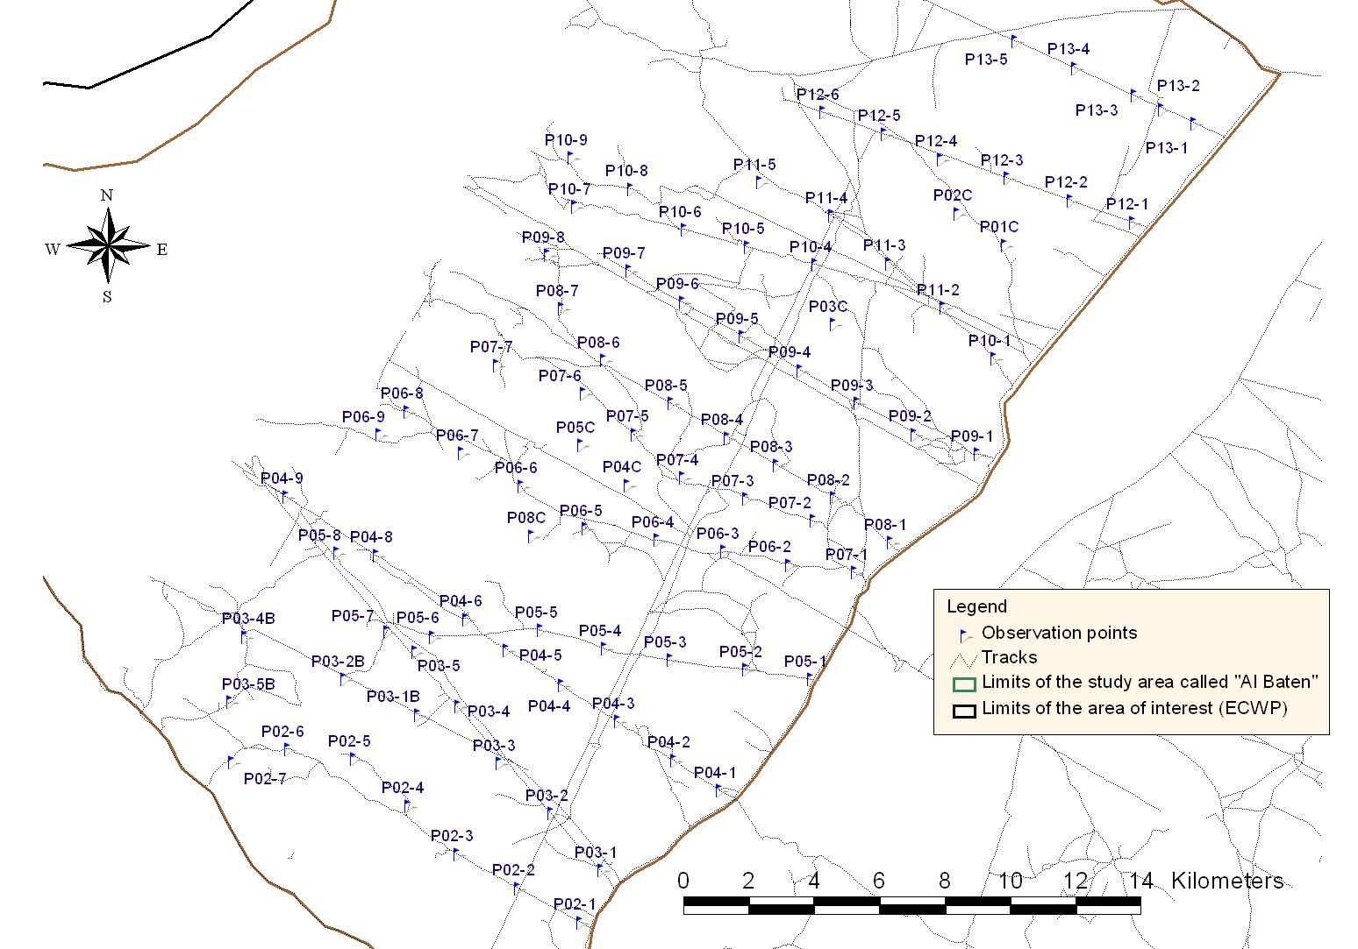
Figure 1: Distribution of the 90 observation points used for displaying male search on Al Baten from 2005 to 2011

- Since 2011: 96 observation points

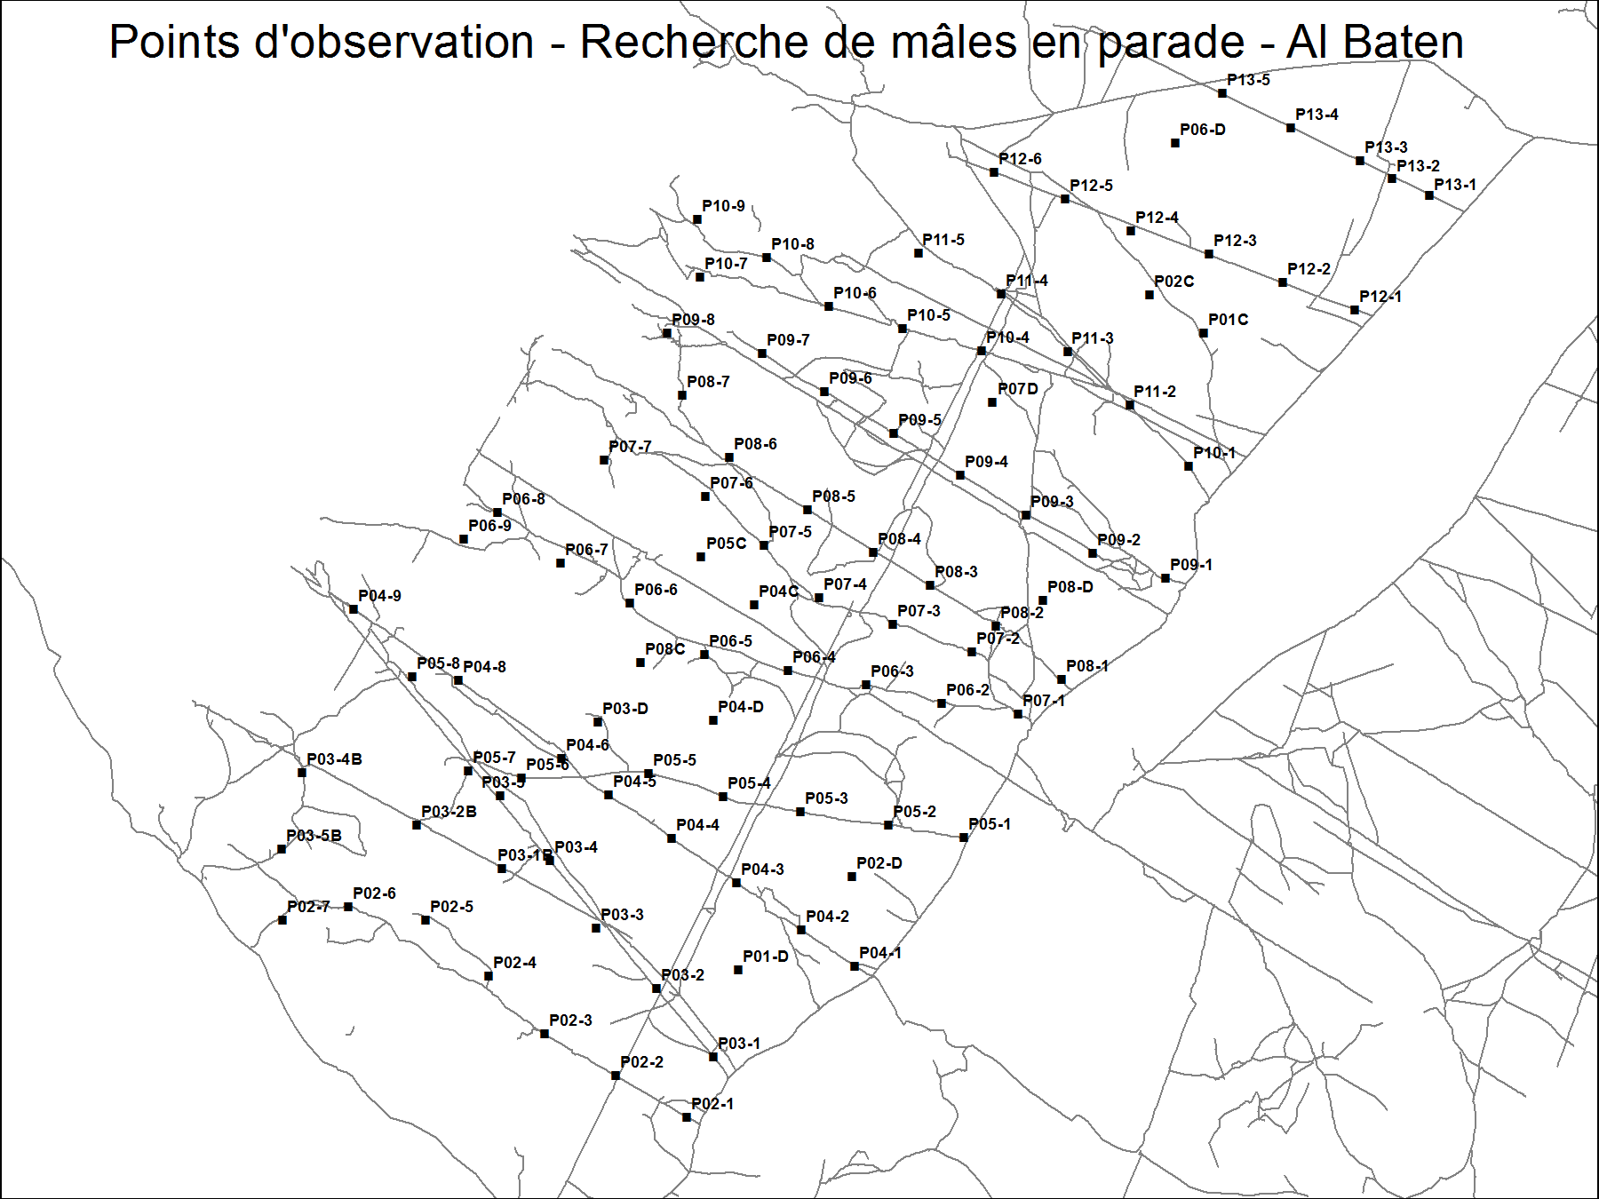
Figure 2 : Distribution of the 96 observation points used for displaying male search on Al Baten since 2011

